# CHAPTER 1

# INTRODUCTION

Project Management (PM) is defined as the application of knowledge, skills, tools, and techniques to project activities in order to meet customer needs and expectations from a project. Web based project management systems are designed to manage and store project information that are used in web-based applications. Web based project management system can surprisingly increase performance, productivity and efficiency within an organization. Since web-based applications can be accessed through any web browser, no desktop installation or updates are required. Today’s rapid technological advancement of IT industries, and globalization, project management solutions are in demand throughout the world as a fundamental force to complete projects within a defined scope, time, and within cost constraints. Today’s most modern project management systems deliver innovative solutions and its management process has the latest tools, techniques, systems and schemes in use. Definitely we could say that project management is a carefully planned and organized effort to accomplish a specific one-time objective. To define and confirm the project goals and objectives we need first to develop a project plan, after that we could easily identify tasks and achieve goals. Later on, quantifying the resources is needed, determining budgets and timelines for completion. Projects usually follow major stages, including feasibility, definition, project planning, implementation, evaluation and maintenance. So, it is better, less time consuming and comfortable to get all the documents from one place. Besides that, the system has to have all documents related to that specific project, but it also has to have the code, right paths, folders and links. The customer needs are basically the most important to understand, how to analyze the requirements, produce a design and go about development and testing so that the system you deliver is a high quality and does what the client wants it to do. Web-based Student Project Management System, is designed with the latest technologies to mitigate these challenges. The project is designed to provide continuous, timeless and boundless communication between project coordinators and students, students and their guides. The project automates routine project activities such as listing and selection of project topics, approval of project topics, project report writing guidelines and report submission, and finally report storage and management. Thus, it will eliminate the duplication and recycling of existing projects by making sure that such projects are rejected automatically at the very point of submission for approval, as well as guarantee high quality and timely completion and submission of students’ projects. Managing and controlling the final year projects of students using manual or traditional process is a very tedious job. The main aim of this project is to create an automated system for managing all the activities of projects. Project management system is a system for managing, controlling, monitoring the final year projects of students. It is a web-based portal or application which is useful for students, project coordinator and project guide. Then students can login into the system using their id and password to get authenticated. Similarly, project guide needs to login into the system using their id and password. Project coordinator is main aspect of the system which will assign different tasks to the students. Project coordinator and project guide is co-ordinate with each other.

In today’s world, nobody takes an initiative to look for notices which are displayed on the notice boards. Many students miss the information about some important notices and updates related to their final year projects. Also, the students are not able to keep track of their project related activities. It becomes very easy if all the details and updates of the project from guides and coordinator are readily available for the students. Managing the final year projects manually is very stressful job. But using simple web portal anyone can carry out their project related work which is the main aim of Project Management System (PMS). It provides students, Project coordinator and Project guides a simple web portal to manage and monitor the overall project activities. All the modules of the system have a unique user id and password. Then any module can login into the system using their id and password to get authenticated further.

The World Wide Web (WWW) is a platform for all the people from all around the world to gain and deliver knowledge and information. The Web is also becoming more popular because of the effectiveness in the use as an administrative and management tool in many institutions. This technology is the main key in the idea of developing an online system.

**CHAPTER 2**

**LITERATURE REVIEW**

* **The Web-based Student Project Management System (WSPMS), School of Science, Akanu Ibiam Federal Polytechnic Unwana**, is similar to a typical course management system (CMS), or a project management system (PMS). The comprehensive comparisons of CMS had been made by various parties like Unal and Bremer, especially the two commonly employed systems: Moodle and Blackboard.
* **ClockingIT is a general PMS with free licensing**. It provides basic management functions like task management with priority assignment to tasks, so that a project manager can better arrange manpower and plan the schedule of projects. Moreover, it has chat function and forum for ease of communication. At the same time, it provides functionalities to share folders for user to access documents and source code simultaneously. This system also includes some advanced functions like Gantt chart generator which is a standard tool for project scheduling.
* **Clement and Bounds shared similar goals as WSPMS in facilitating the management of final year projects**. Their system focuses on better ways to connect students with potential supervisors before the project allocation starts, and also includes tools for assessment submission and collection which are normal functions in a CMS.
* **Bakar et. al. reported their experience in developing and using final year project management system at Universiti Kebangsaan, Malaysia.** Their system consists of three major modules which include: user profile, project monitoring and appointment setting modules. WSPMS contains similar functionalities and also incorporates additional modules like project allocation, file repository and online communication.
* **HKU CS Project Management System is a project management system developed in the University of Hong Kong, Department of Computer Science.** The system can show project information, news, schedules and project allocation. In its main page, the system offers functions such as blogs, calendar and form downloading. Also, there is a list of projects and related information, as well as some advanced functions such as providing a virtual machine for students as servers for their final year projects.
* **According to the Royal Institute of British Architects (as cited in Matheu, 2005)**, “The overall role of project management is to harmonise the functions of planning, communicating, monitoring and control in order to meet the project’s overall objectives as defined by the scope, time, cost, quality and client satisfaction”. Communication deals with the producing, issuing and transmitting reports/documents, and chairing meetings with key project participants in order to ensure the proposed timing, method and strategy is made available and understood. Matheu (2005) writes that, In essence, collaboration of various participants in a project is measured by how effectively the communication channels were managed”. Therefore, as conveyed by Matheu (2005), “The responsibilities of the Project Management are to plan, coordinate and control the overall project”. Such duties can be achieved through a good communication and information management tool, such as a Web-based project management system (WPMS).

**AIM AND OBJECTIVES**

Prior to this research, most of the processes and activities involved in students’ final year projects, were completely carried out manually and relied heavily on traditional methods for communication, assessment, submission and management of finished projects. These, undoubtedly, often resulted in poor quality projects, duplication or recycling of existing projects, prolonged report writing, untimely submission of finished projects, and unstructured and poor management of project works. The aim of this research, therefore, is to provide remedy to these challenges. Aim will be achieved through the design and implementation of a fully functional Web-based Student Project Management System which will provide continuous, timeless and boundless communication between project coordinators and students, students and their guides.

**CHAPTER 3**

**TOOLS AND TECHNOLOGIES USED**

The latest tools and technologies are being used in order to develop the application which makes the design look more effective and attractive. The technologies used are secure, reliable and robust. Below are the descriptions of the technologies used in developing the application.

**Operating System**

Operating system is the most important thing in every computer. It serves as the platform for all the programs to run and interact between the hardware and the software of the system. There are a lot of operating systems available to install such as Windows, Linux, and Mac OS.

**Open-source Operating System**

The common and main idea about open source is that it is free and cost-minimized. The users of open source are everywhere and there are a lot of people who can help regarding issues of open source. It is also reliable in terms of security and architecture.

**Programming Language**

One of the main components to be taken into account before developing a web page is to select the language to be used. A programming language is a language used to communicate and interact with computer. It is used to communicate with the machine, by creating programs, applications, scripts, or other set of instructions that control its behavior. The sights and sounds created on web page are all created using programming languages, among them are PHP, Python, and ASP.Net.

**HTML**

HTML stands for Hyper Text Markup Language. Not to be mistaken, HTML is not a programming language but it is a markup language for web pages. HTML documents are the web pages and the HTML tags and plain text describes the web pages. A web browser will read the documents by interpreting the tags and then displays the content of the web pages. In between the HTML opening and closing tags, the author may create the pages by adding images and objects or designing text structure by putting headings, paragraphs. Even though HTML language seems like the most simple and basic, it can embed scripts in languages that can affect the behavior of the web pages such as JavaScript. To enhance the appearance and layout of the pages, the author can use Cascading Style Sheets (CSS) on the HTML web pages.

**JavaScript**: JavaScript is a scripting language or in another word, a lightweight programming language. It is designed to perform dynamic tasks. The web browser with JavaScript enabled only will interpret the script as the web pages being loaded. Because a JavaScript can perform dynamic tasks, it can be used to add effects by reading and changing the content of an HTML element accordingly as response to the user’s action. JavaScript also helps the server by performing some simple actions on the client-side to prevent the server from doing extra processing.

**PHP**

PHP stands for Hypertext Preprocessor. PHP is developed as open-source software. It is one of the server-side scripting languages among Perl, Python and Java. PHP scripts are executed on the server. Therefore, a PHP page will not display the PHP codes on the client interface because it is executed on the server. One of the advantages of PHP is that it can run on different platforms or operating systems (Windows, Linux, Unix, etc.). PHP also supports many databases (MySQL, Informix, Oracle, Sybase, etc.). It is also compatible with almost all web servers used today (Apache, IIS, etc.). As open-source software, PHP is free to download and use. It is also easy to learn and runs efficiently on the server side.

**SQL Database**

SQL is short for Structured Query Language. SQL is the language used to communicate with the database. Using SQL, the author can create database, and access, insert and manipulate data in the database. There are standard SQL commands that are essential in communicating with database such as "Select", "Insert", "Update", "Delete", "Create", and "Drop". Top SQL databases today are MS SQL Server, Oracle, DB2, and MySQL.

**MySQL**

MySQL is an open-source database server system. MySQL supports to use on many platforms such as Windows, Linux and Mac OS. MySQL is one of the world's top databases as it is used by the world's largest organizations including Facebook, Google, Adobe, Twitter and Wikipedia. The advantages of MySQL that attract authors to use are its high performance, high reliability and its ease of use. MySQL also has the function of indexes which improves SELECT queries speed tremendously. MySQL is open-source software so it is free to download and use.

**SYSTEM REQUIREMENTS AND SPECIFICATION**

**Hardware Requirements:**

|  |  |
| --- | --- |
| **Hardware type** | **Specification** |
| Computer processor | Pentium-IV |
| Computer Hard disk | 40 GB HDD |
| Computer RAM | 512 MB RAM |
| Speed | 1.1 GHZ. |

**Software Requirements:**

|  |  |
| --- | --- |
| Operating System–OS | Windows XP |
| Application Server | Apache |
| Front-End – Design Screens | HTML5, CSS3 |
| Database/s | My SQL |
| Backend Language | PHP |
|  |  |

**Non-functional requirements:**

* **Efficiency requirement**: When the project management system will be implemented, students, faculties and HOD will be accessing the system and the tasks related to the project will be done fast and smoothly.
* **Reliability requirement**: The system should accurately perform all module logins, and all other functions and maintenance.
* **Usability requirement**: The system is designed for students, faculties and HOD to perform various tasks in effective way.
* **Organizational requirement**:

Implementation requirements: In implementing whole system it uses html in front end with php as server-side scripting language which will be used for database connectivity and the backend ie the database part is developed using mysql.

Delivery requirements: The whole system is to be delivered with a span of time with weekly evaluation by project guide.

**CHAPTER 4**

**IMPLEMENTATION**

**System Architecture**

Figure 1 refers to the architecture of a Three-Tier Client/Server. In overview, the flow of the system can be described as follows. When a user enters the URL to access Online Management System in the Web browser, the browser will send a request to the Web server to fetch an HTML page or execute a PHP script. A PHP scripts uses SQL queries to access the Online Management System database tables and sends dynamically generated HTML pages back to the client’s browser. One of the compelling reasons for developing Online Management System is to provide a user-friendly Web environment in managing all the participants and projects. The system shall be made up of the following four components:

1. Client side

2. Server side

3. Database back-end and web-based administration tool

4. Graphical front-end

**Three-Tier Client/Server Architecture**

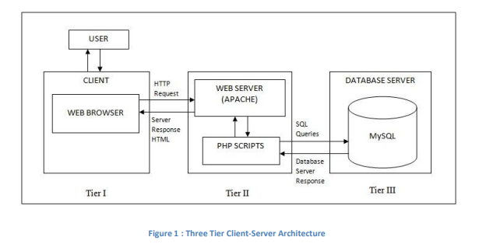

In Figure 1, Online Management System architecture is ordered into three tiers: the user interface in the client browser, the Web server, and the database server. The functional description of each tier in the system is as follows:

**First Tier: The Interface**

• As viewed from the client’s web browser, the interface is build by HTML pages with Java Script support.

**Second Tier: Web Server**

• For this system, an Apache web server is used with the PHP module to support the back ends in third tier. The PHP scripts will process the user input, generate SQL queries to access the database and then the Apache will compile and execute the output in dynamically generated HTML pages.

**Third Tier: Database Server**

• In the third tier, the MySQL database server will receive requests from the second tier to execute SQL statements. The server accesses the database files to retrieve the stored data and then sends the queried data back.

**Client-Side Architecture**

As for the HOD, faculty and students, the task of uploading their projects and allocations of students are made easier with this system. There will be no more hardcopy forms to be filled and, all will be done online. This group may also view student profiles and give the student’s marks. The system is planned to be able to allow the lecturers to view the student’s online submissions. The Online Management System is a Web-based application where it uses any web browser to interact with user. So the important component on client side is the web browsers (e.g. Internet Explorer, Mozilla Firefox, Google Chrome). After all the back-end process, the HTML will be used to generate dynamic web pages and the JavaScript will validate user input. Scripting language used here is HTML with JavaScript enabled to ensure the compatibility with the server side.

**Server-Side Architecture:** On the server side, the Online Management System will have several database tables where all the data and information are stored and also some dynamically generated tables using MySQL database in Linux environment. MySQL is used to compose the queries to access the database. The server will be running on PHP scripts with embedded queries to interact with the database.

**Project work flow process:**

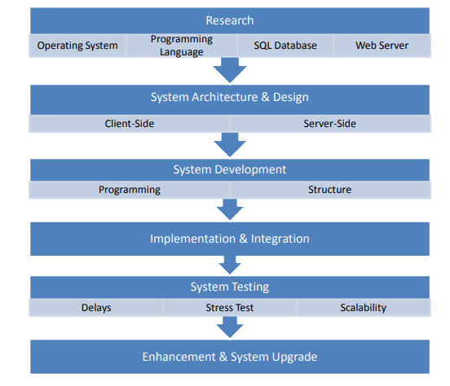

The work flow process takes place in the following steps:

1. Research
2. System Architecture and design
3. System development
4. Implementation and integration
5. System testing
6. Enhancement and system upgrade

**STUDENT MODULE**

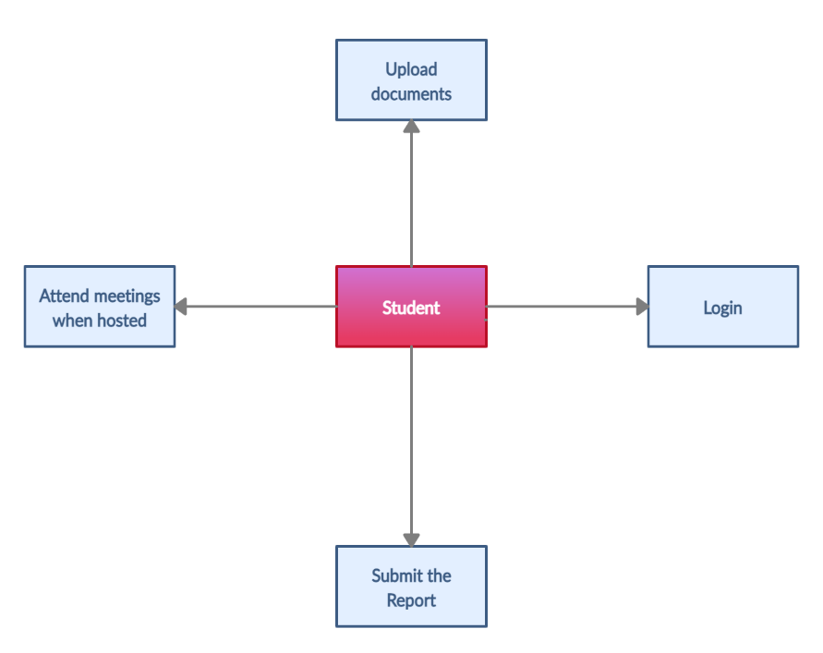

**Student access:**

* Project
* View skill matrix
* Mail
* Logout

**FACULTY MODULE:**

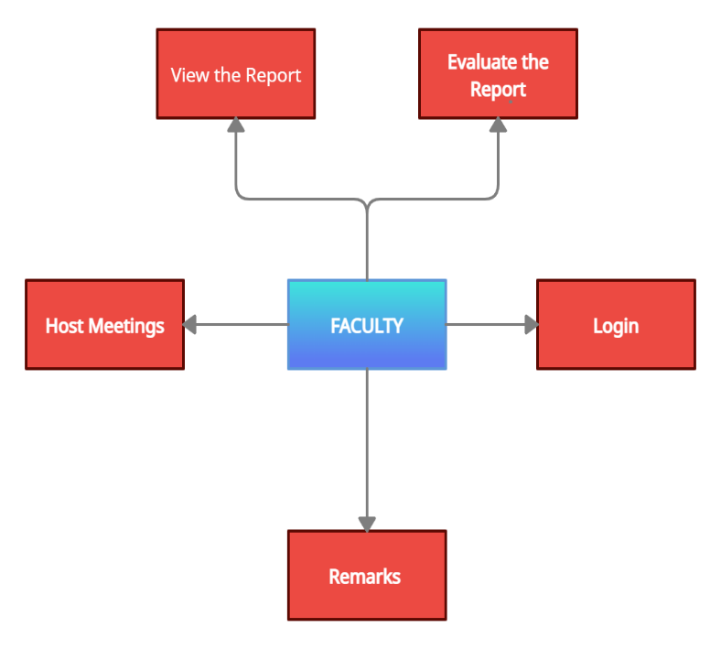

**Faculty access:**

* Skill matrix
* View
* Mail
* Meeting
* Allocate marks
* Logout

**ADMIN MODULE:**

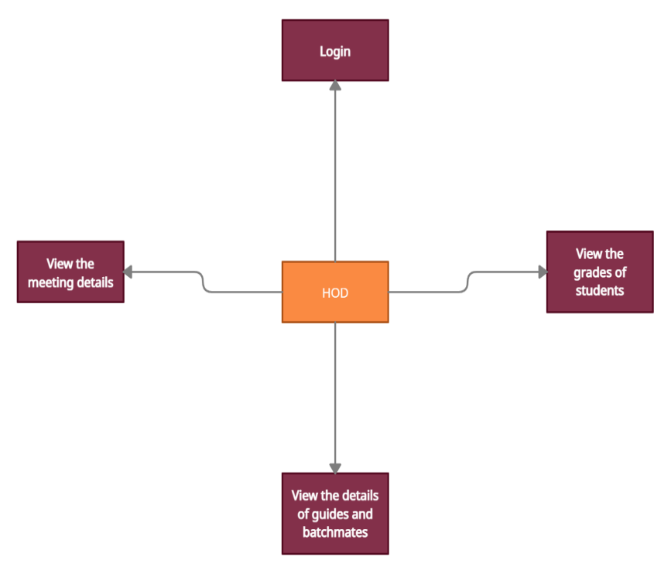

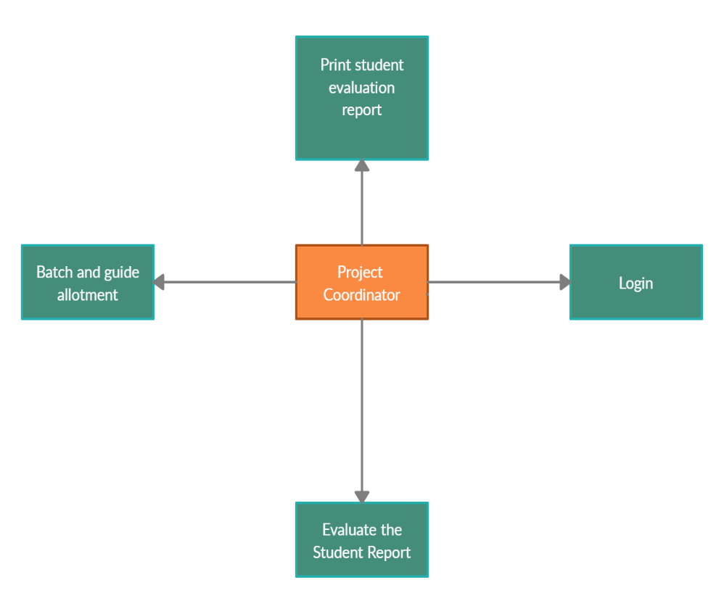

**Admin access:**

* Add student
* Add faculty
* Search student
* Search faculty
* Allocate
* Skill matrix
* Reports
* View marks
* Logout

**TEST CASES:**

|  |  |  |  |
| --- | --- | --- | --- |
| **S. No** | **Action** | **Input** | **Output** |
| 1. | Login page | ADMIN, STUDENT,  FACULTY.  Requirements: ID, password. | Login to particular welcome pages of student, faculty, admin. |
| 2. | Add student | Student id, name, email, phone no, year, branch, password. | Student is successfully added to the database. |
| 3. | Add faculty | Faculty id, name, email, qualification, password. | Faculty is successfully added to the database. |
| 4. | Search student and update | Enter the student details. | Student details are fetched and the information can be updated. |
| 5. | Search faculty and update | Enter the faculty details. | Faculty details are fetched and the information is updated. |
| 6. | Allocate faculty | Student id, project id, faculty id. | Allocate students to faculty. |
| 7. | Reports | Meeting id, project id, student id, date, time, description. | Meeting details is fetched. |
| 8. | View marks | Student id, marks. | Student marks gets displayed and it can be exported to excel and can be printed for reference |
| 9. | View | Select the Student name, feedback option. | Project proposal: Synopsis can be downloaded.  Quick mail: Feedback can be sent, |
| 10. | Mail | Compose mail. | All the sent and received mails can be viewed. |
| 11. | Meeting | Student id, faculty id, date, time, description. | Meeting is scheduled. |
| 12. | Allocate marks | Select the student list and allocate the marks. | The marks allotted can be viewed by Admin and can be used for further reference. |
| 13. | View skill matrix | Select the faculty name | View all the details of faculty and request for allocation. |
| 14. | Search project | Enter the project title and search for any duplicates of project. | Output 1: Project not found you can upload the project. Output 2: Duplicates exist. |
| 15. | Project proposal | Upload project files, presentations, and other files. | Files are uploaded and the faculty will be able to download it. |
| 16. | Log out |  | Exit from the login pages. |

**CHAPTER 5**

**RESULTS AND DISCUSSIONS**

First, when a user types the URL, it lands on a page where landing there are login columns. From there, depending on the access level of the user, the site will redirect to their respective dashboard site. The access level will also determine the functions available for that user.

**IMPLEMENTATION:**

**ADMIN MODULE:**

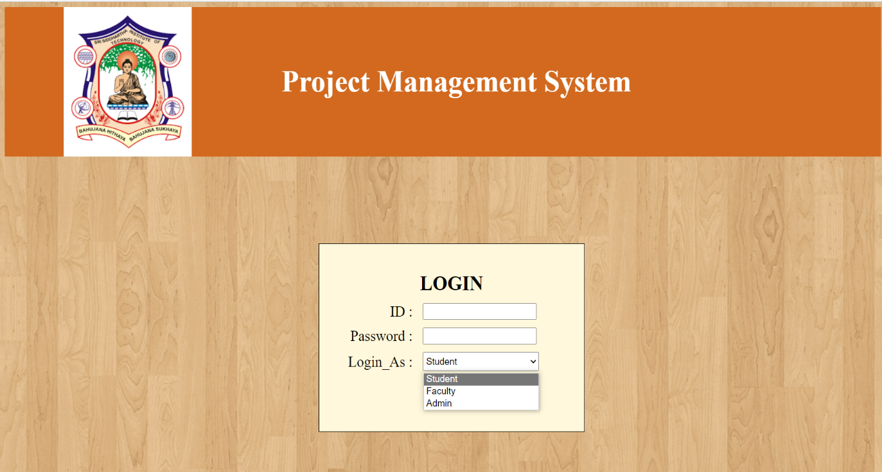

Fig 1: Login page

Login to particular welcome pages of **Student, Faculty, Admin**.

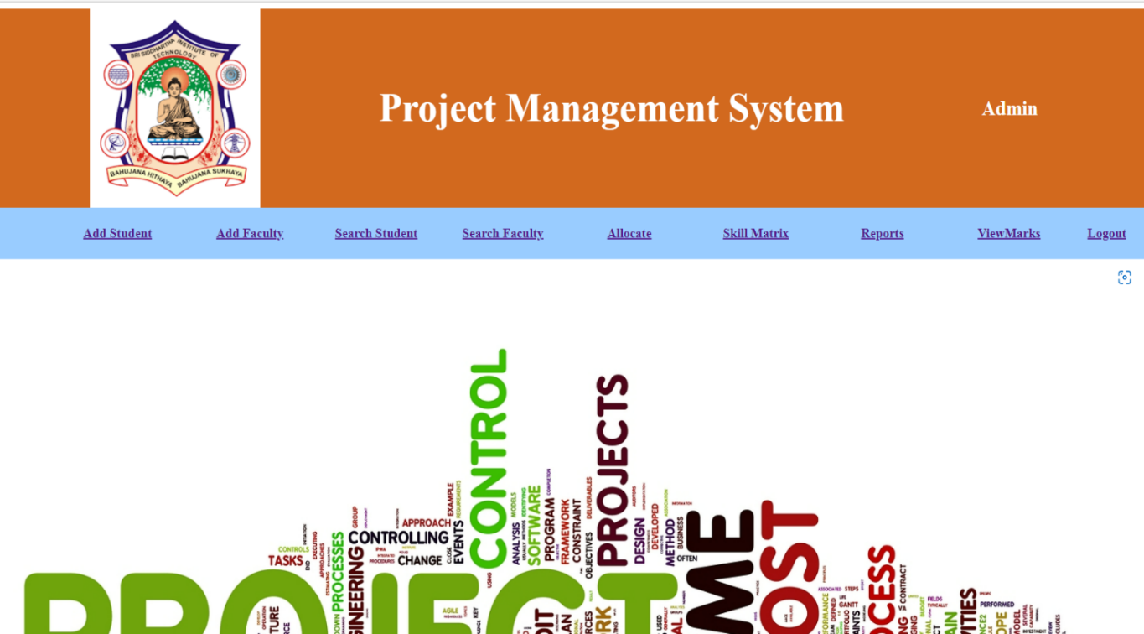

Fig 2: Admin Welcome screen in Admin/HOD panel

Admin user interface consists of following operations

* Add Student
* Add Faculty
* Search Student
* Search Faculty
* Allocate
* Skill matrix
* Reports
* View marks

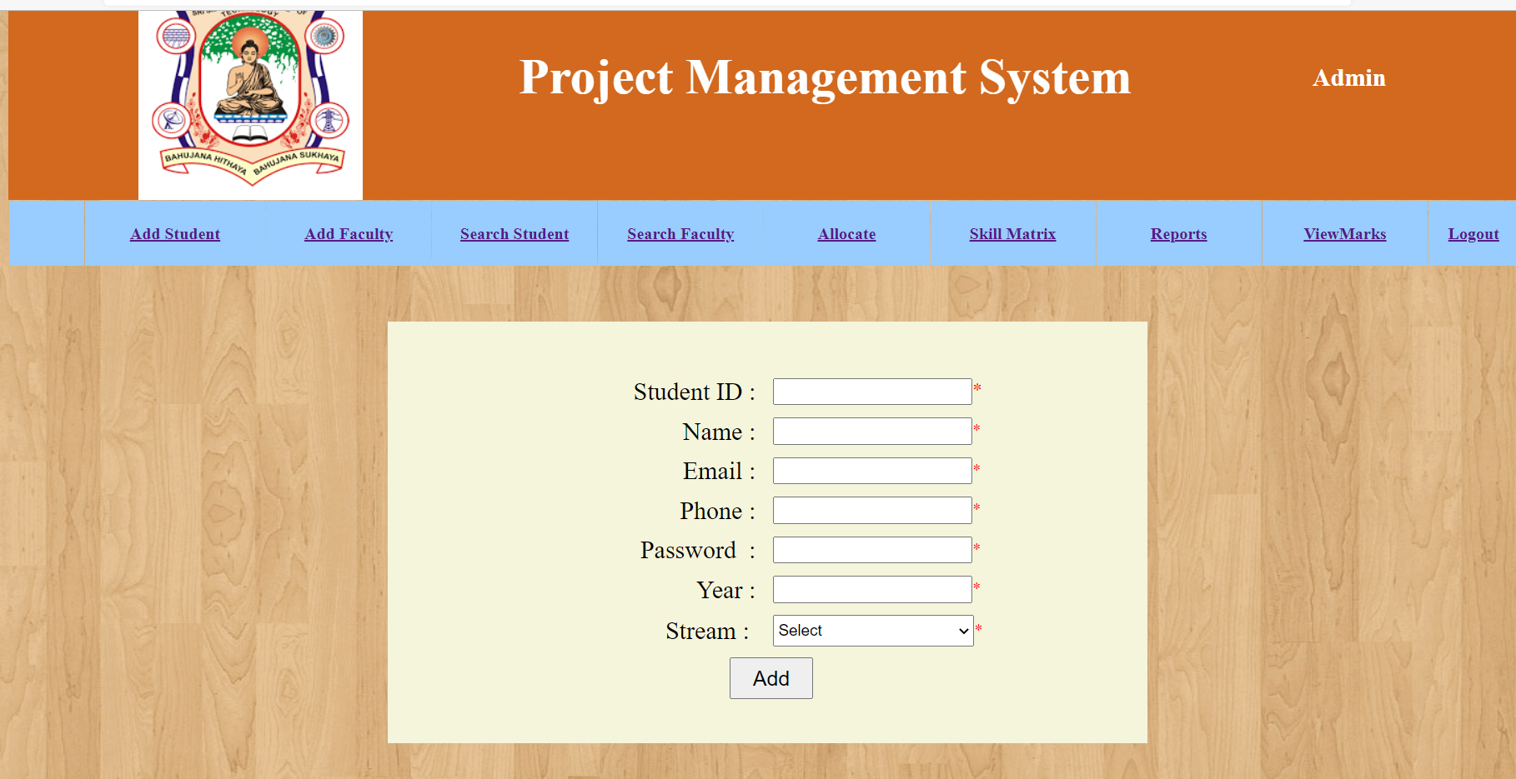

Fig 3: Adding student in Admin/HOD panel

* Student id, name, email, phone number, year, branch, password are the requirements to add a particular student to the database.

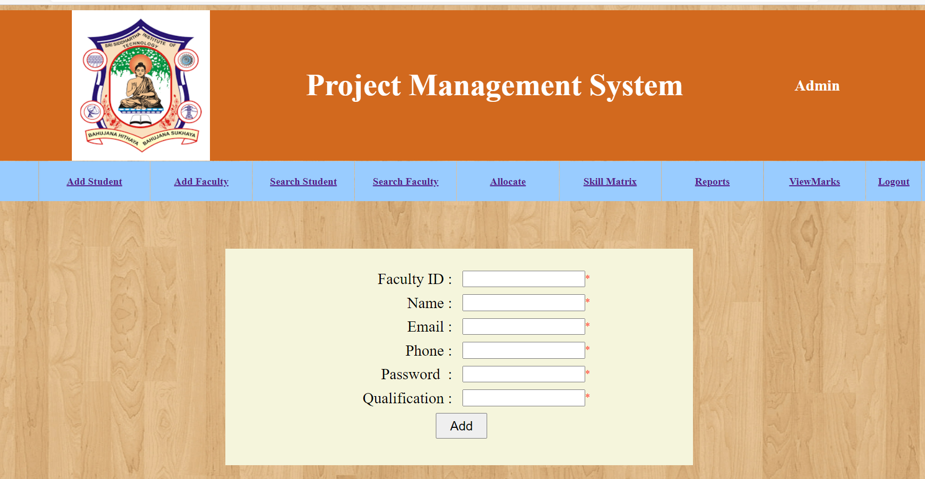

Fig 4: Adding faculty in Admin/HOD panel

* Faculty id, name, email, phone number, password, qualification are the requirements to add a particular faculty to the database.

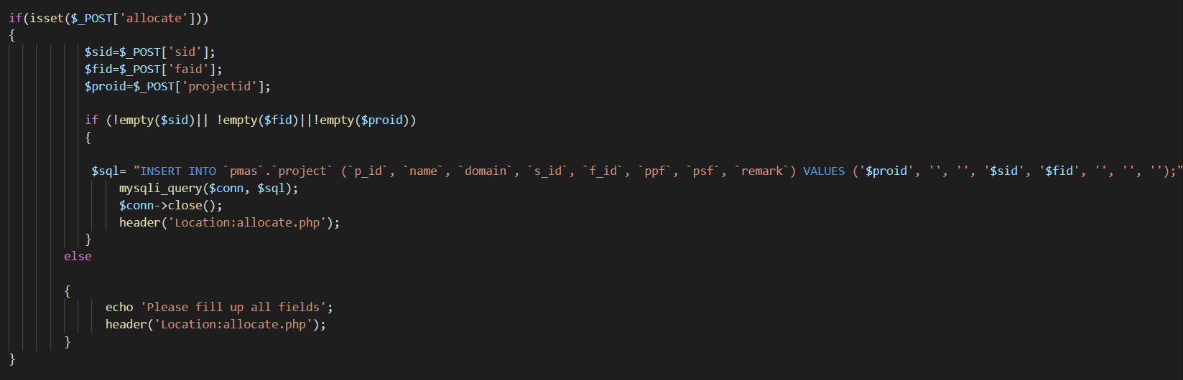

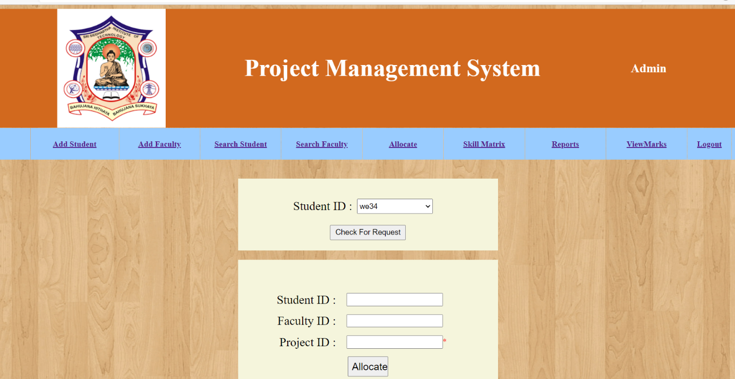

Fig 5: Allocation of faculty in admin/HOD panel

* Student id, project id, faculty id are the necessary requirements for the allocation of faculty based on research field to a particular student.

**FACULTY MODULE:**

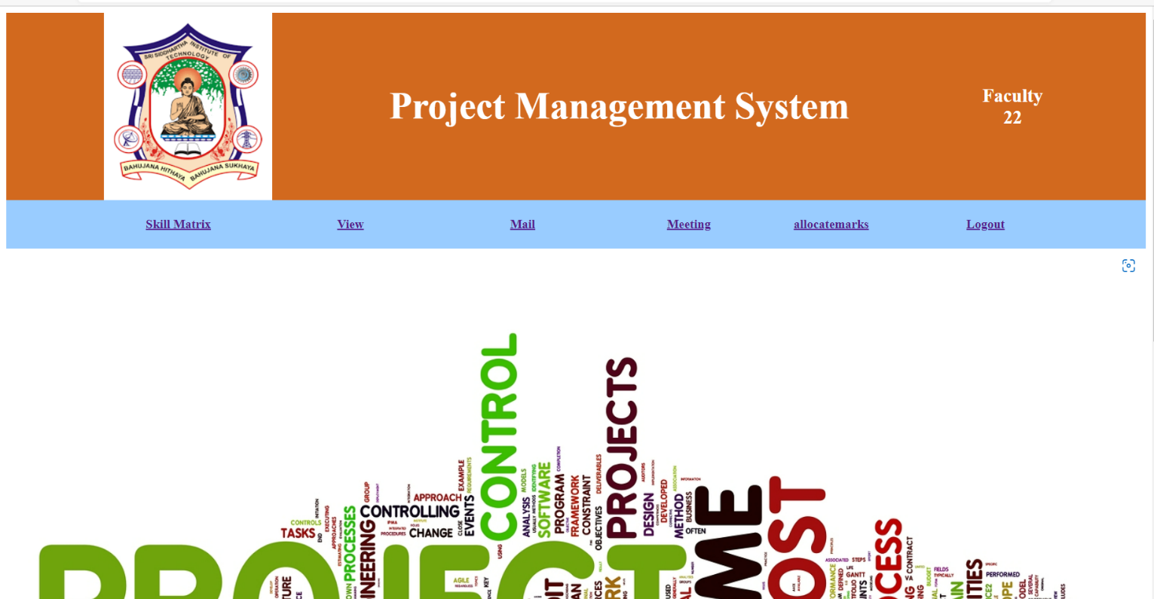

Fig 1: Welcome screen of Faculty

Faculty user interface consists of following operations

* Meeting
* Allocate marks
* Skill matrix
* Mail
* View

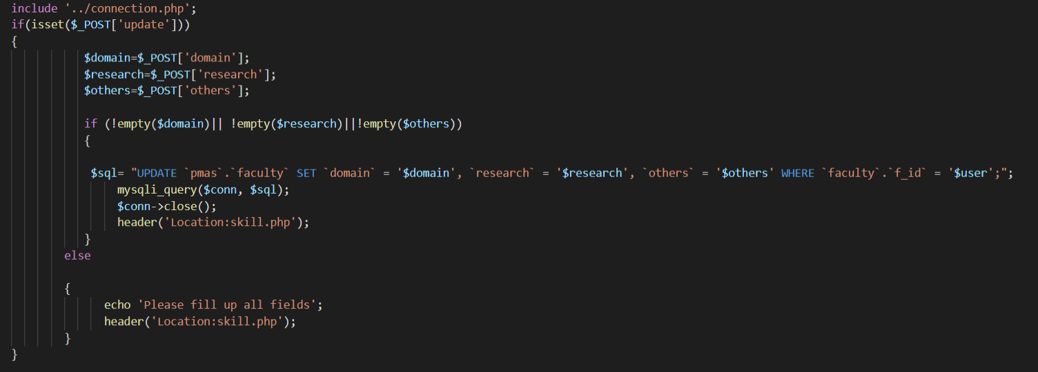

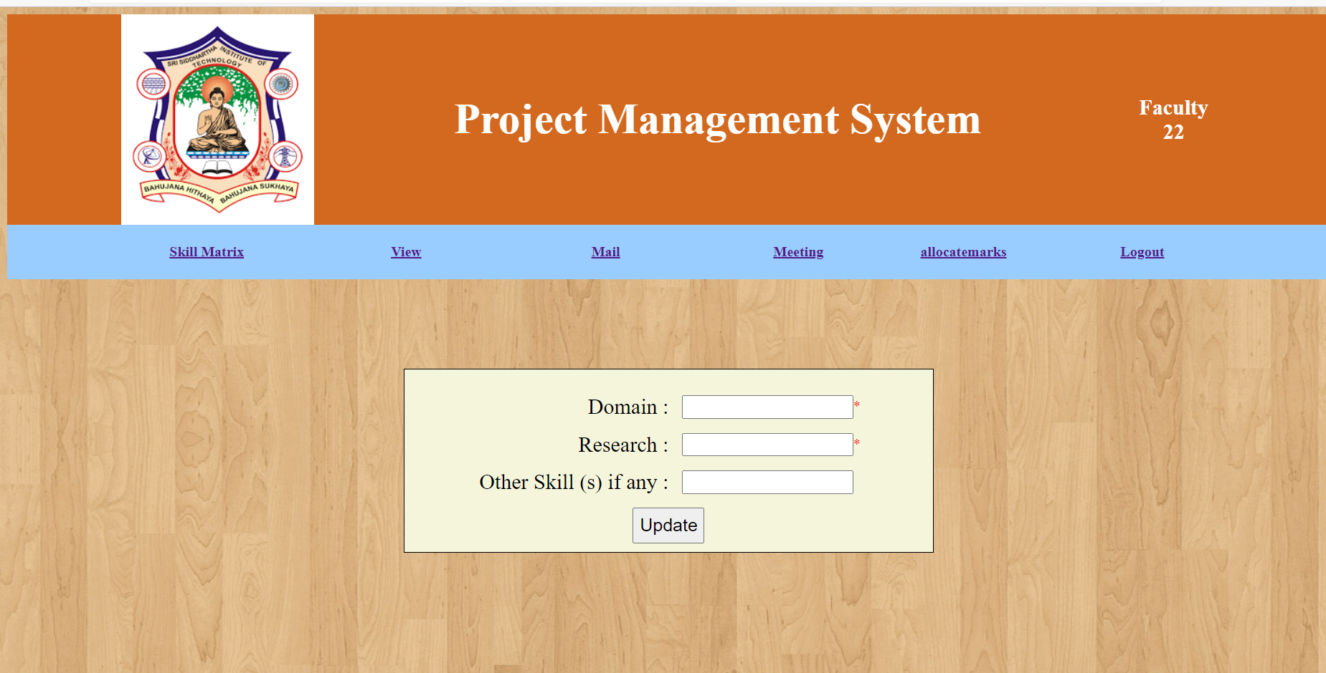

Fig 2: Upgradation of skills of faculty

* Includes the details of faculty like their Domain, Research field and any other skills.

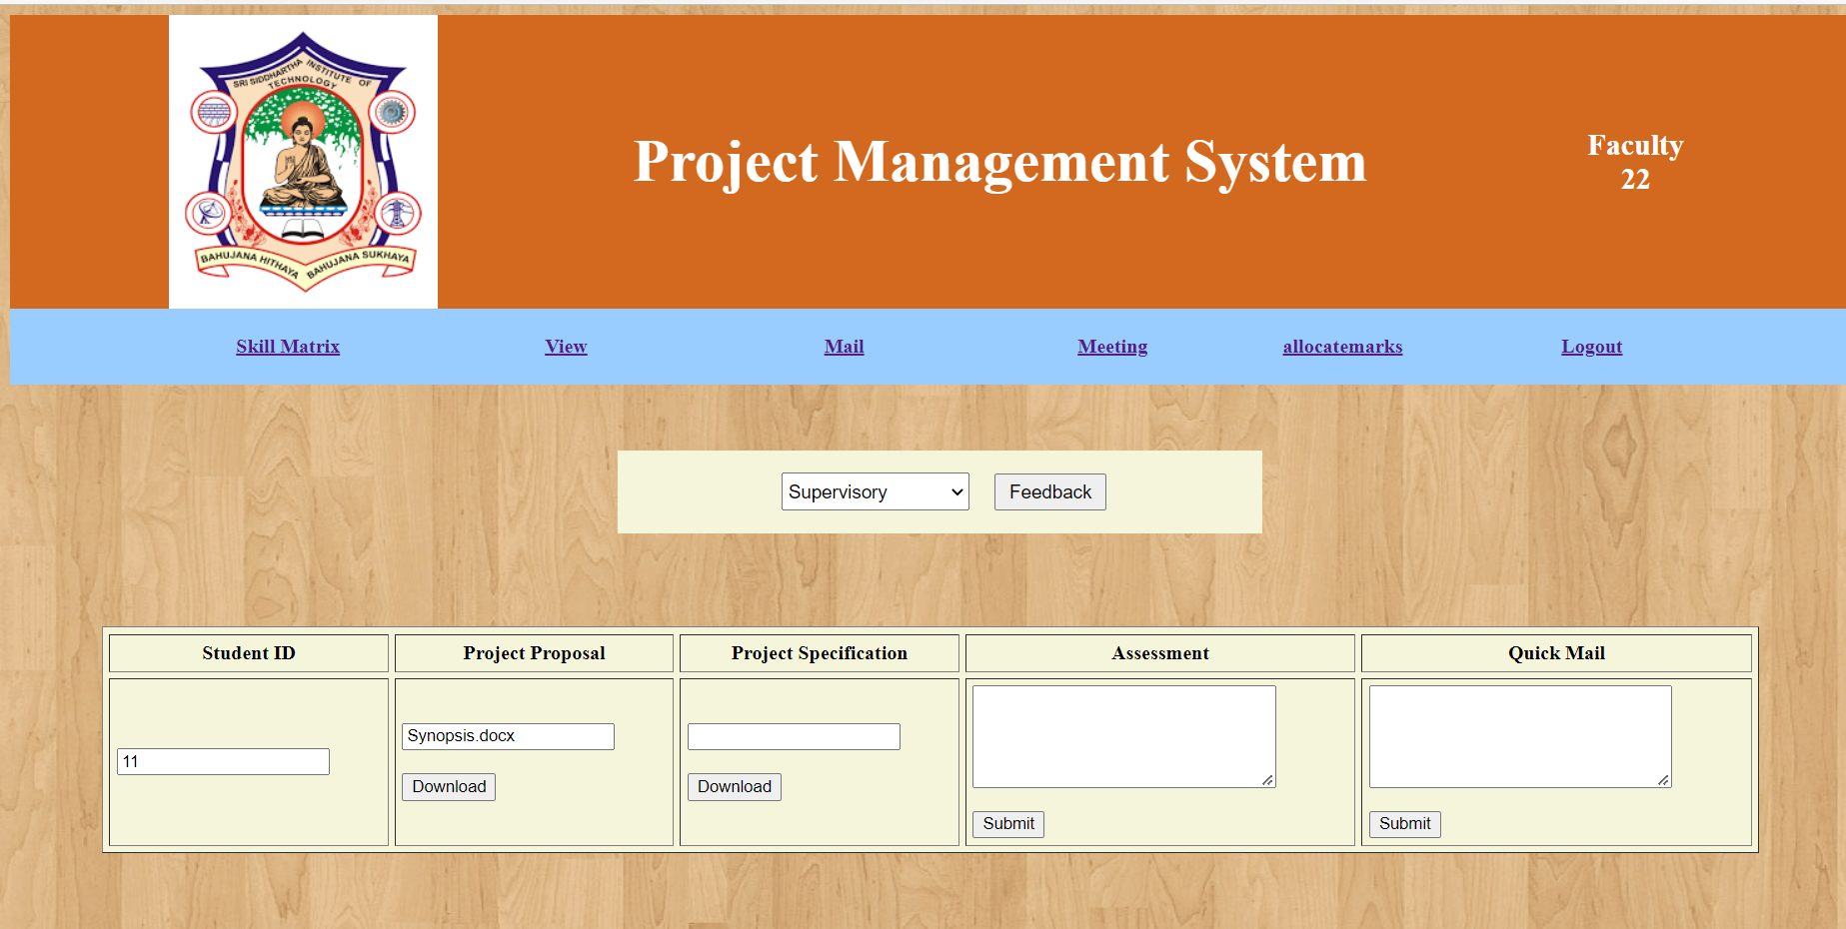

Fig 3: Downloading project report, Quick mail and Assessment.

* The faculty can view all the details related to project and view the project reports, abstracts, presentations and can download it. Also, can send any remarks related to project.

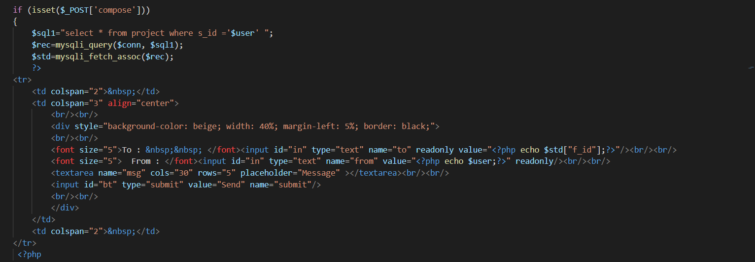

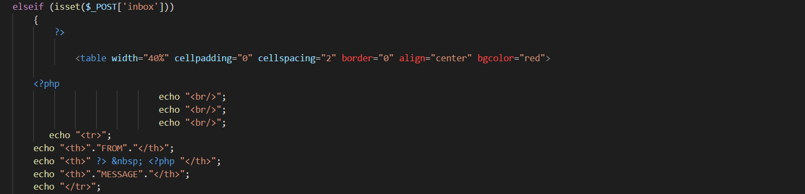

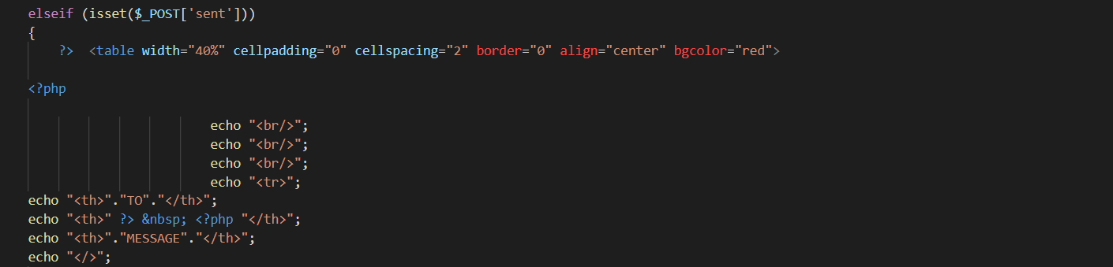

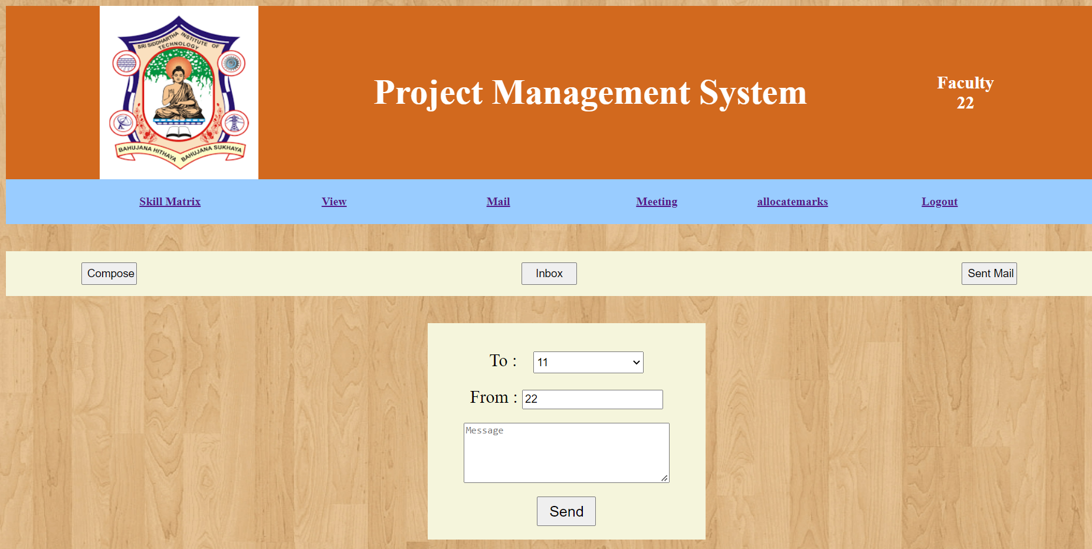

Fig 4: Communication between student and faculty.

* The Faculty can send mails to their students regarding any updates about their projects.

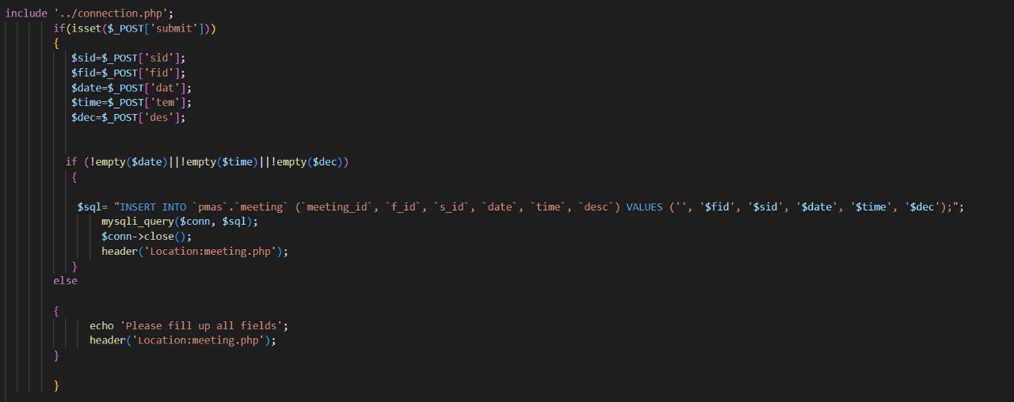

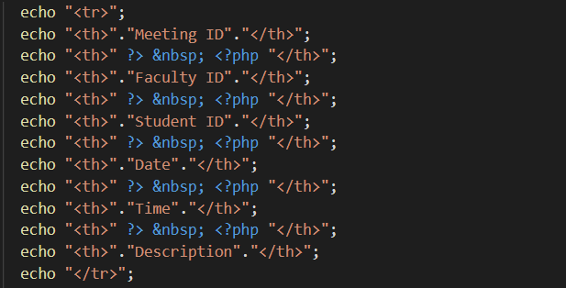

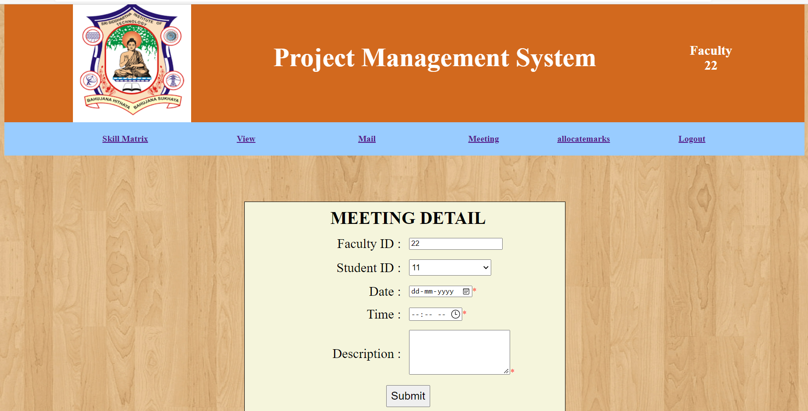

Fig 5: Meeting message for students

* The faculty can conduct meetings about the projects.

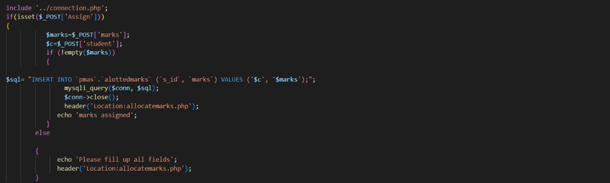

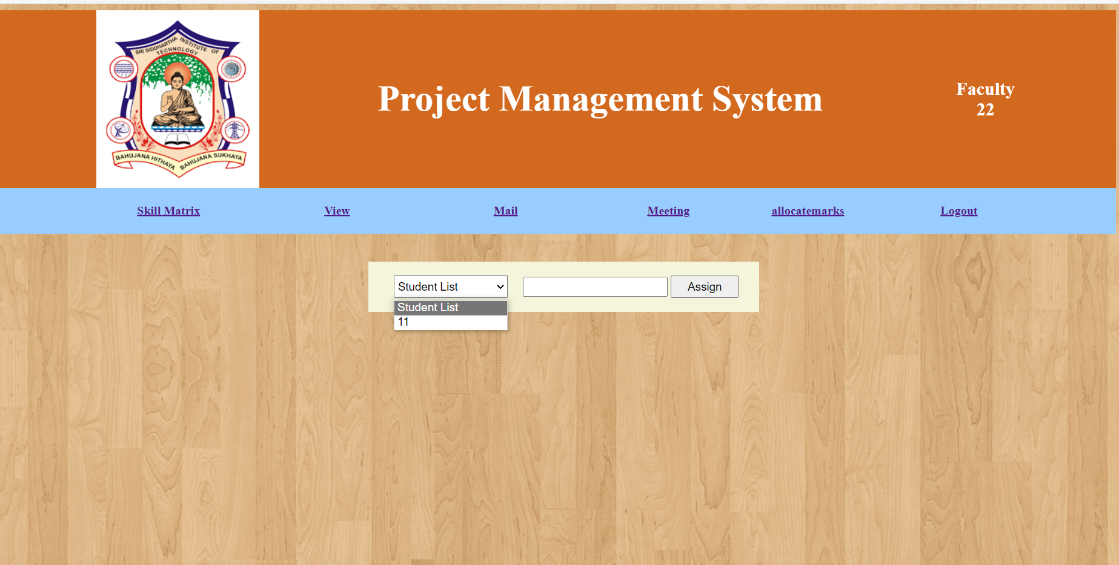

Fig 6: Allocation of marks to students

* Select the student list and allocate the marks. The marks allotted can be viewed by admin and can be used for further references.

**STUDENT MODULE:**

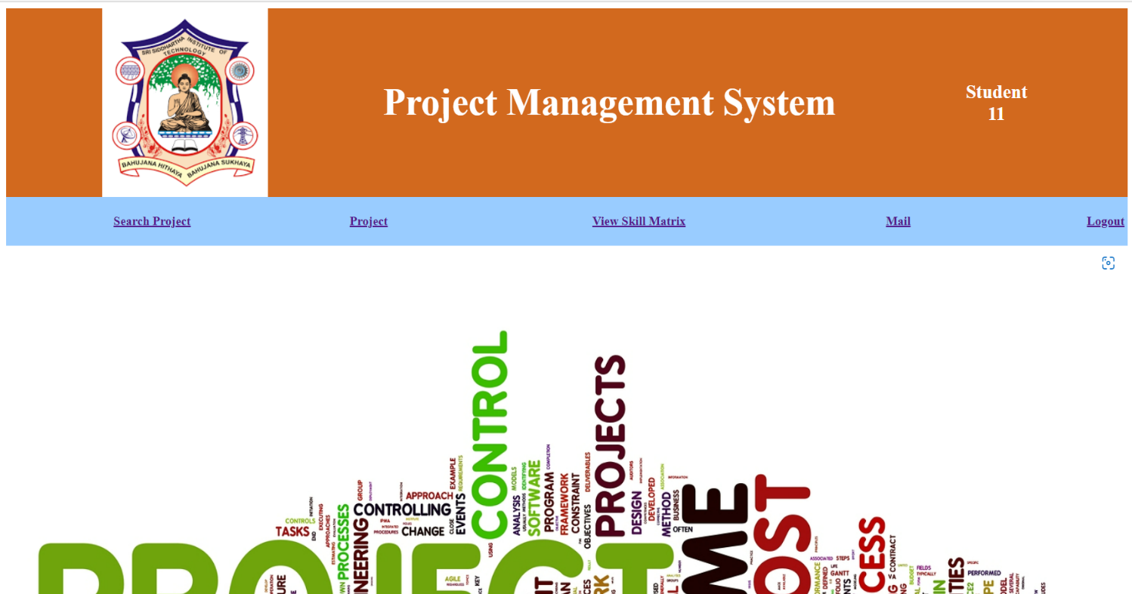

Fig 1: Welcome screen of Faculty

Faculty user interface consists of following operations

* Mail
* Search project
* View Skill matrix
* Project

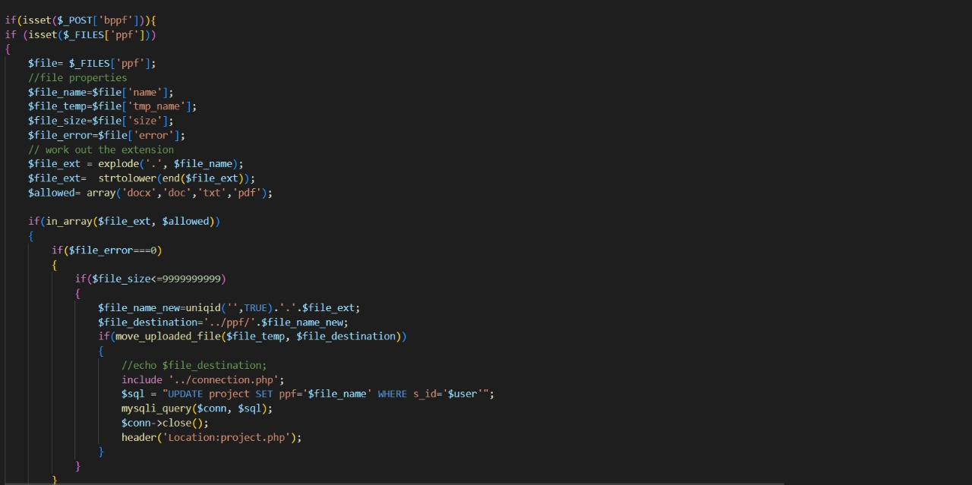

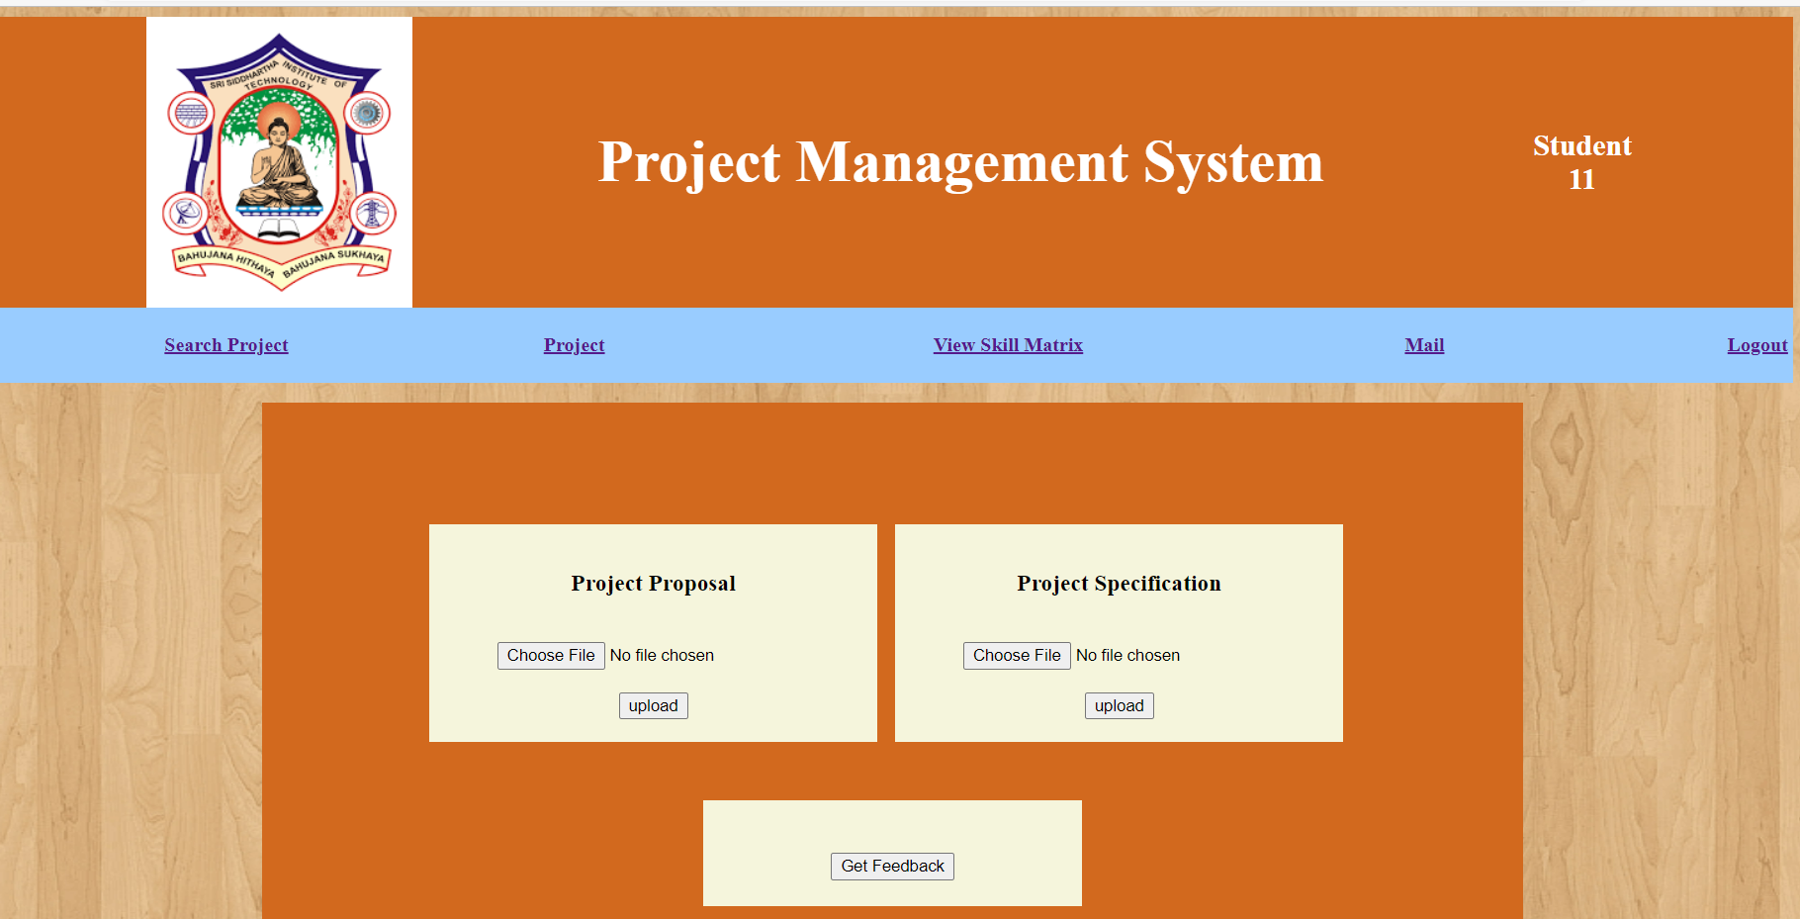

Fig 2: Uploading project report by student.

* The student can upload the documents related to their project i.e, reports, abstracts, presentations and can ask for feedback.



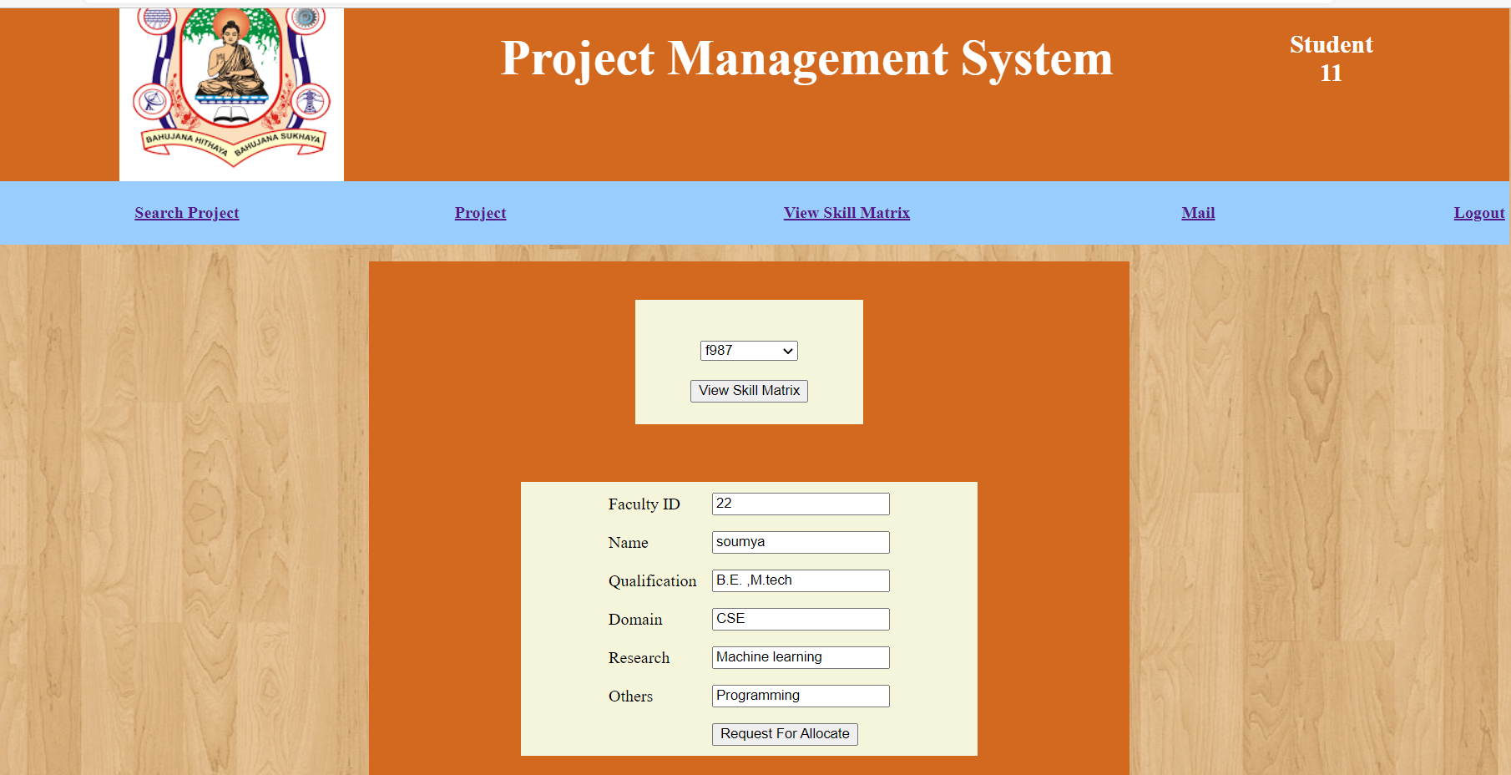

Fig 3: Request for allocation of guide

* View all the details of faculty and request for allocation.

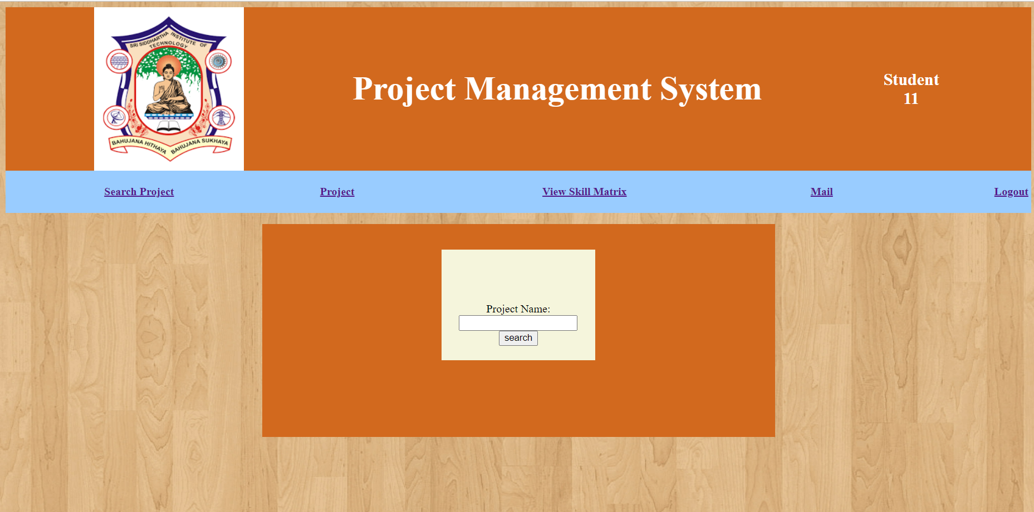

Fig 4: Search the project name to identify if duplicate exists.

Enter the project title and search for any duplication of the project.

And the expected outputs are:

1. Project not found you can upload the project.
2. Duplication exists.

**RESULTS:**

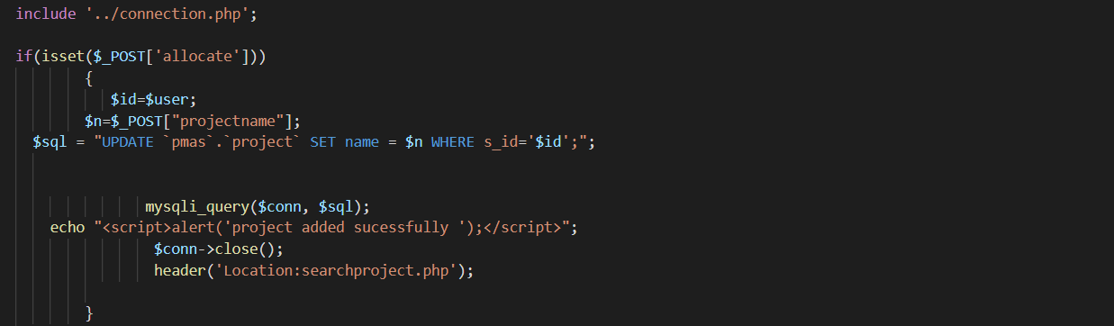

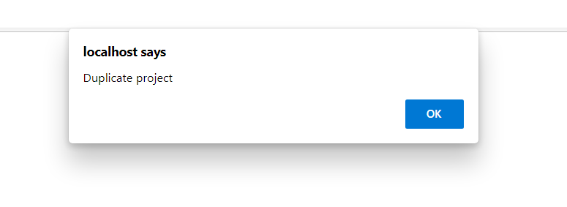

Fig 1: Identification of duplicate project.

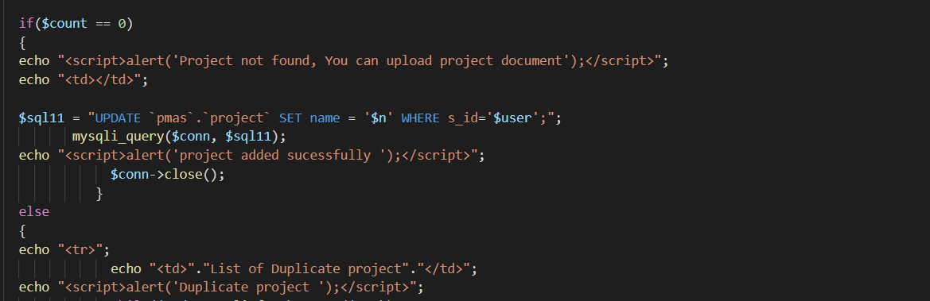

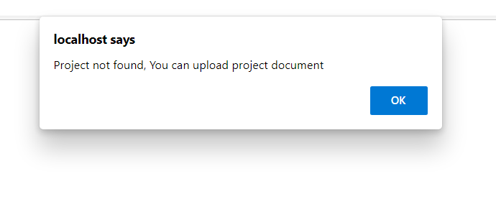

Fig 2: Project can be added successfully.

**CONCLUSION & RECOMMENDATIONS**

**Conclusion**

A web-based Online Management System will be introduced to provide a comfortable environment of management. This project is a comprehensive solution to the problems faced by the manual management of projects, this increases the performance of all the management. All the participants can interact with each other and exchange the information online. The feasibility of the project is guaranteed so this project should really be developed and implemented. The Online Management System is hoped to perform very well in enhancing the quality of management. The WSPMS management system can significantly reduce the workload of the project coordinator. The tasks of arrangement, announcement, collection and assessment can be done automatically using the system. On the other hand, the system provides convenience for both guides and students throughout the process of final year project. First, guides and students can better communicate via the messaging tools in the system. Guides can also easily keep track of the progress of students with the project management module and file sharing functions. Finally, guides can provide grades using the system.

**Recommendations**

There are much more can be done for this system. Currently the system is having some limitation as it is not fully automated in functioning. The system may also provide a means for the participants to communicate in real time online.